H.K.PEIRIS

IT13116002

4th Year

Lab - 03

AWS MYSQL DB

ESBPII

Creating a MySQL DB Instance and Connecting to a Database on a MySQL DB Instance

1. Sign in to the AWS Management Console and open the Amazon RDS

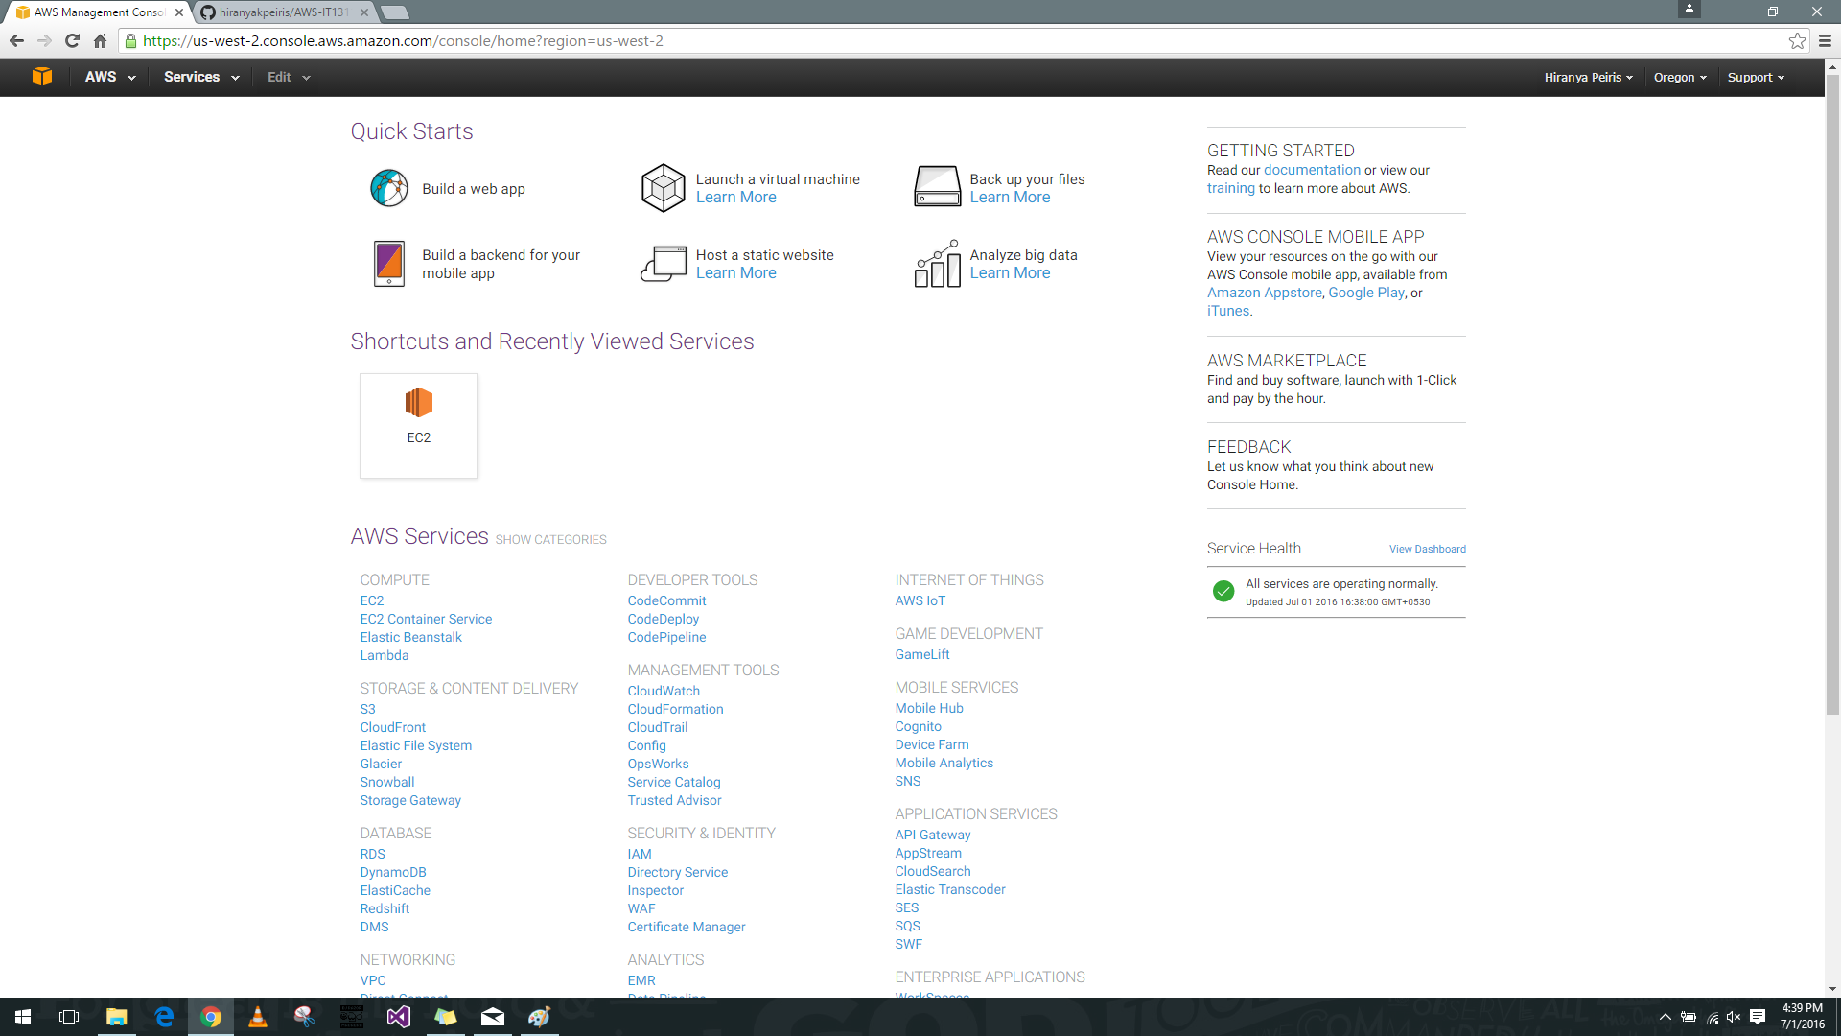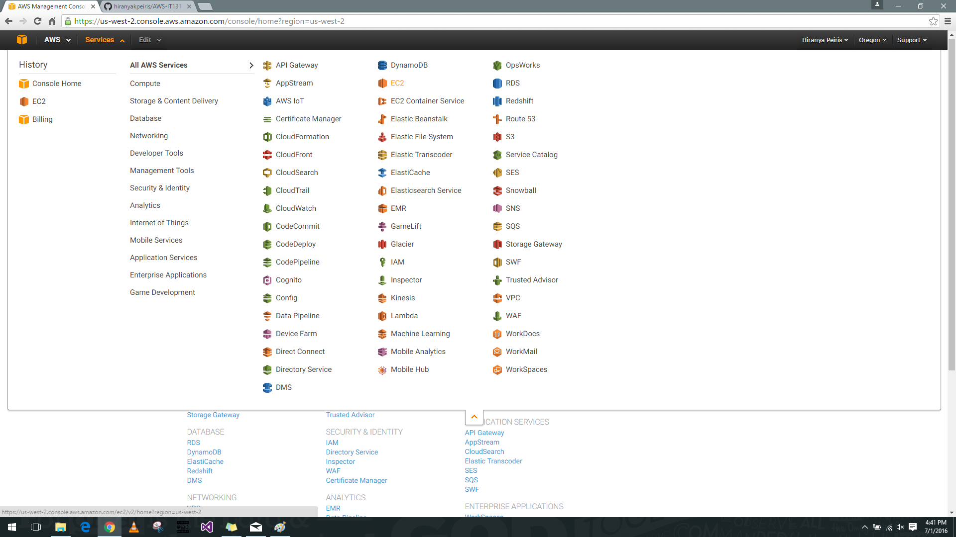

1. In the top right corner of the Amazon RDS console, choose the region in which you want to create the DB instance. In the navigation pane, choose Instances then choose Launch DB Instance.

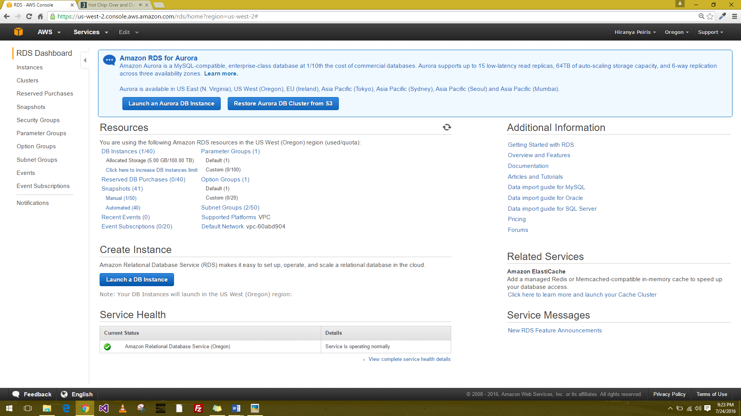

1. The Launch DB Instance Wizard opens on the Select Engine page. Select the DB Engine and your plan.

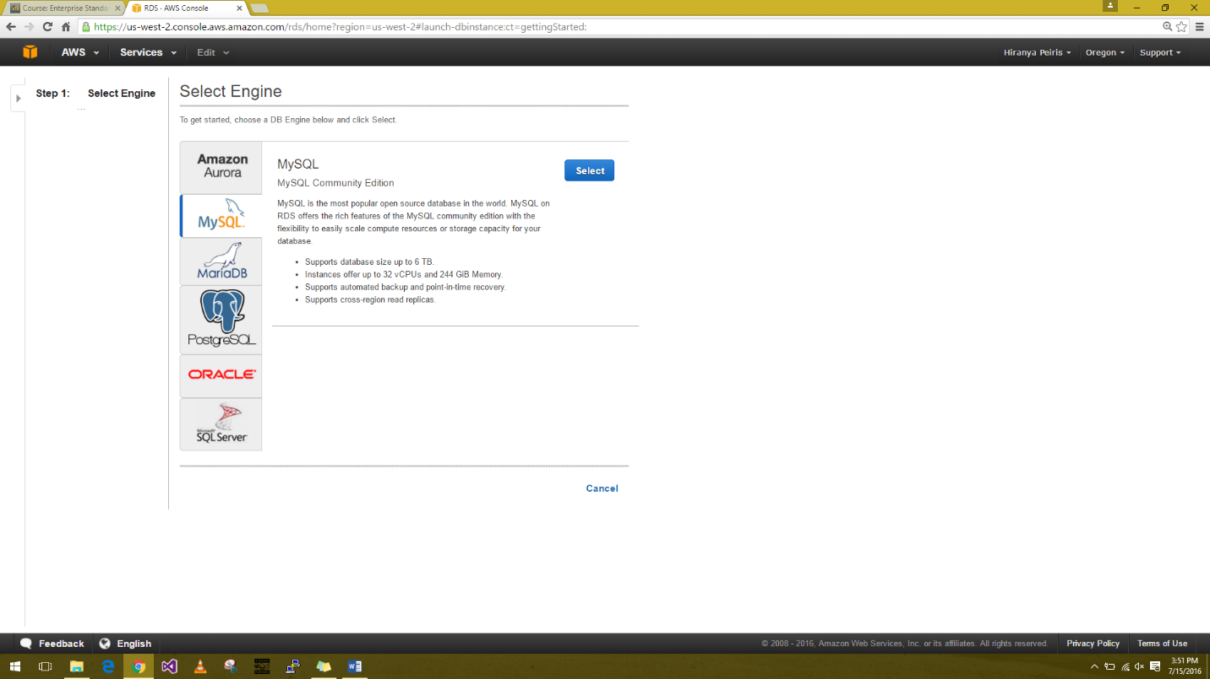

1. Specify DB Details page, specify your DB instance information.

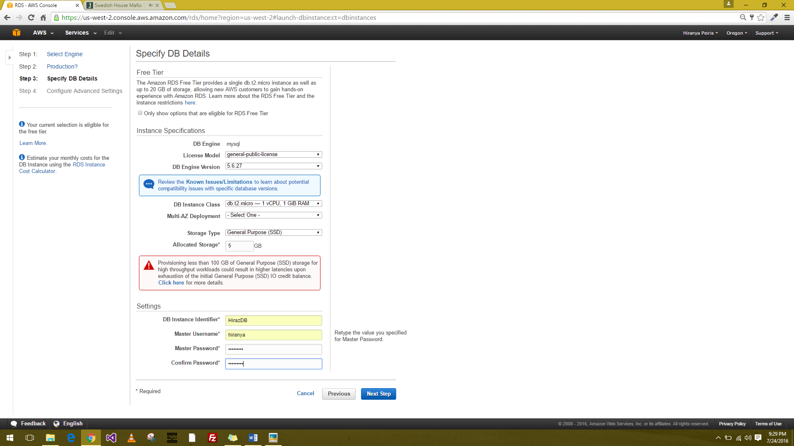

1. Configure Advanced Settings page, provide additional information that RDS needs to launch the MySQL DB instance

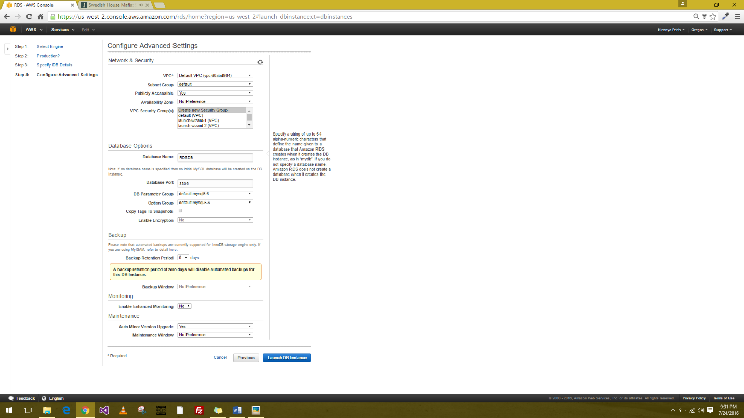

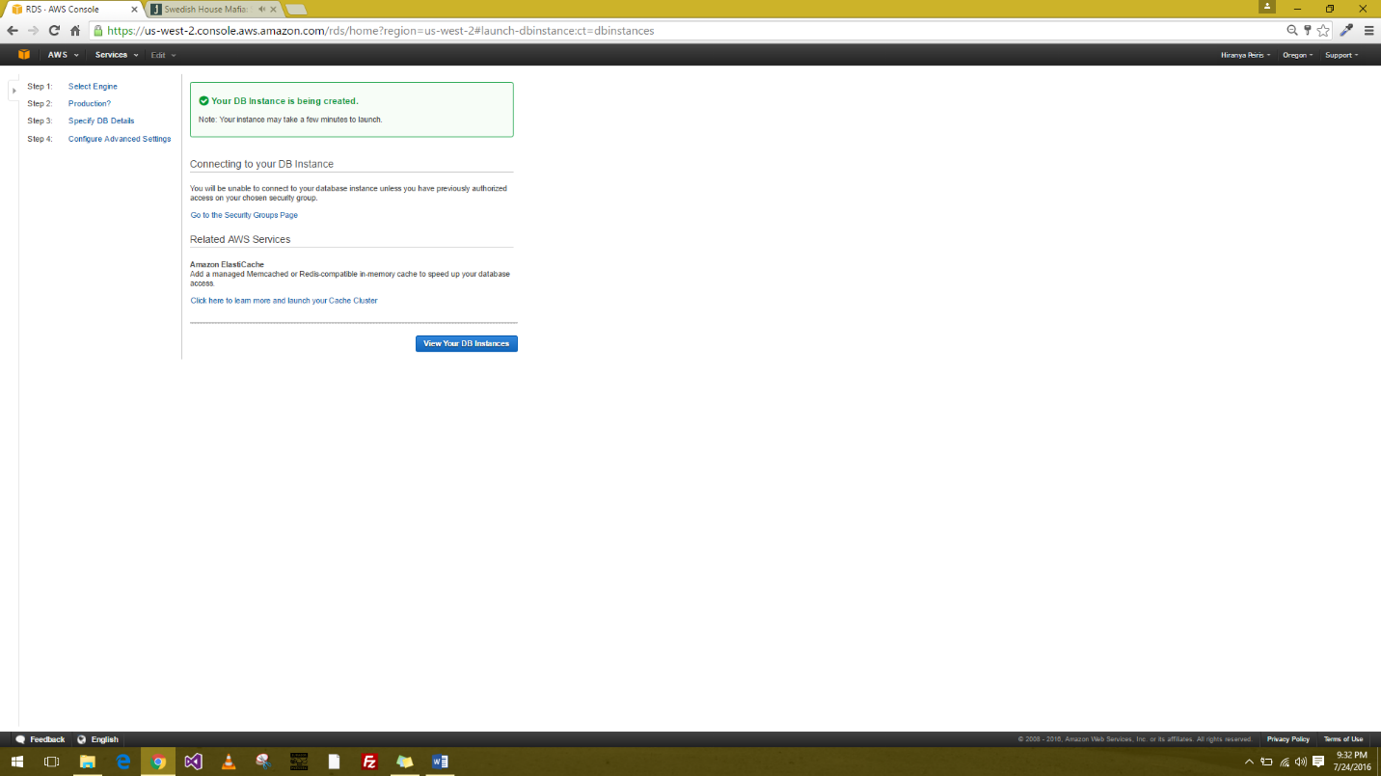

1. 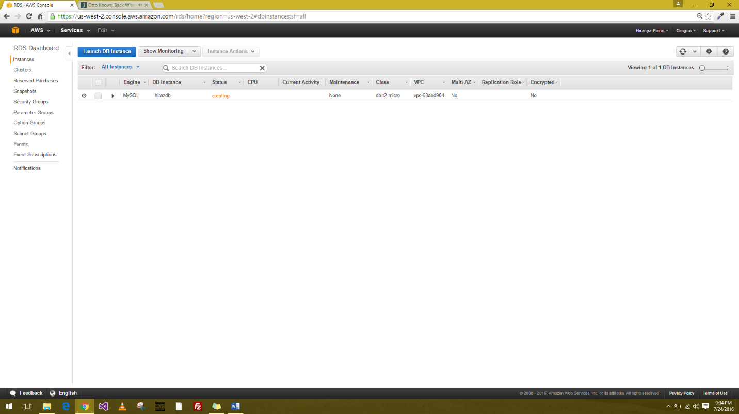The DB instance will have a status of creating until the DB instance is created and ready for use. When the state changes to available, you can connect to a database on the DB instance.

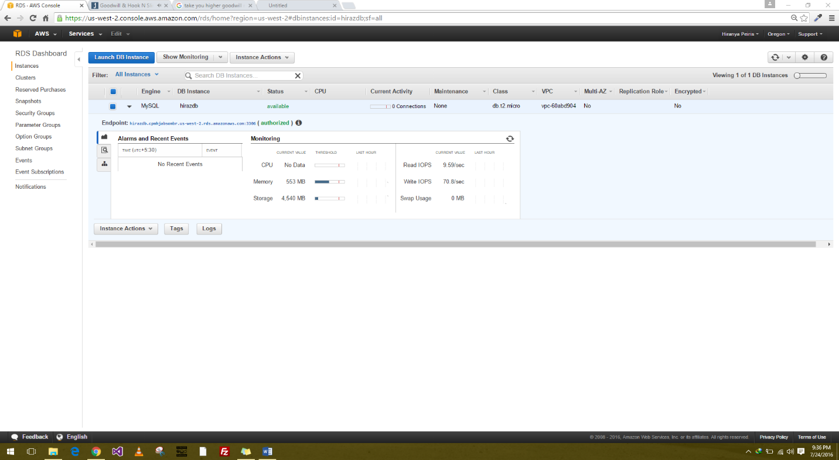

1. Connect to a database on a DB instance using SQLyog

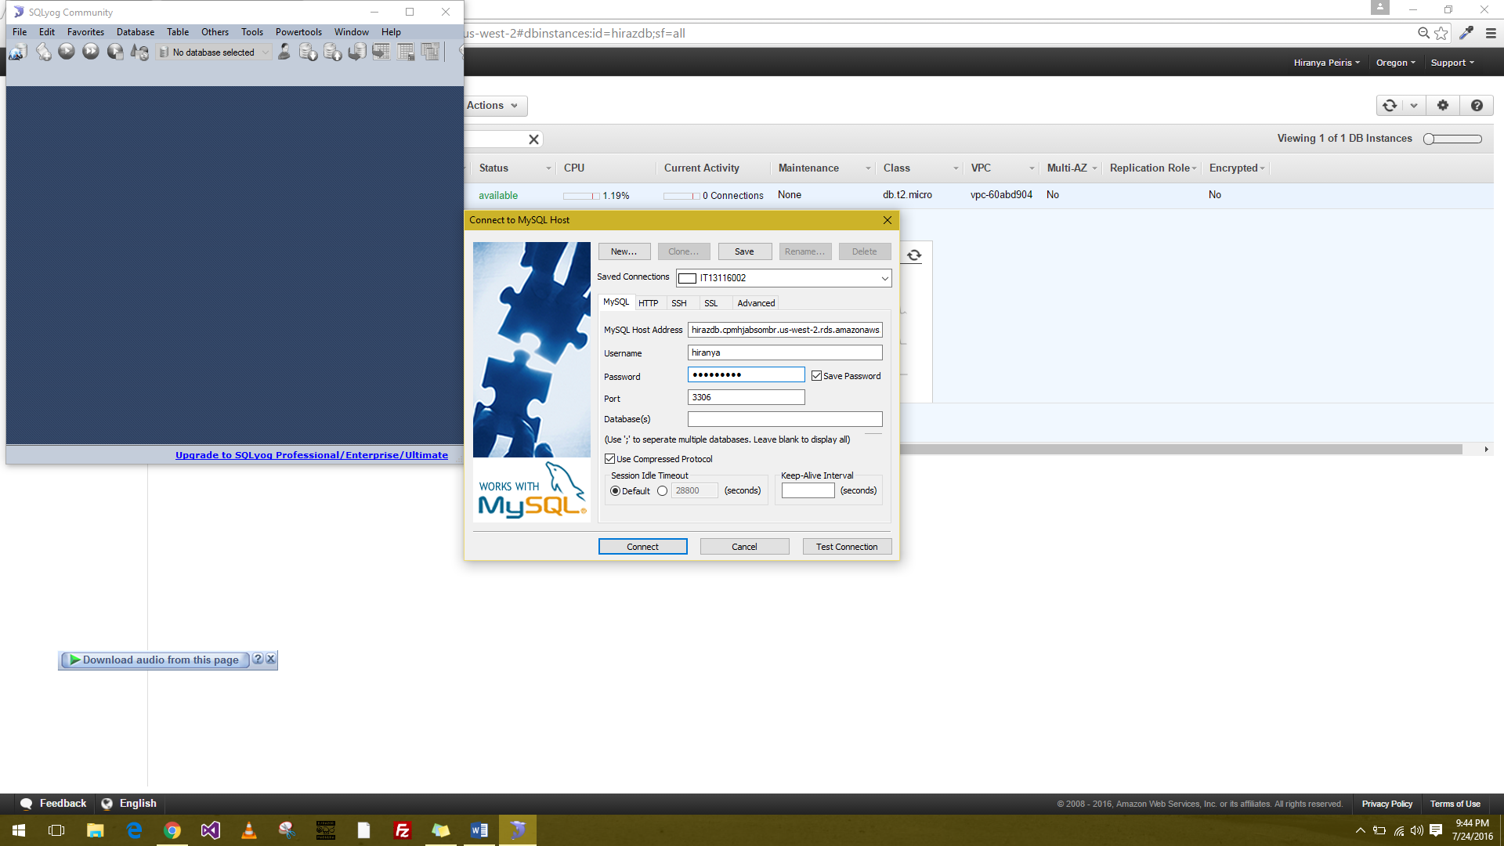

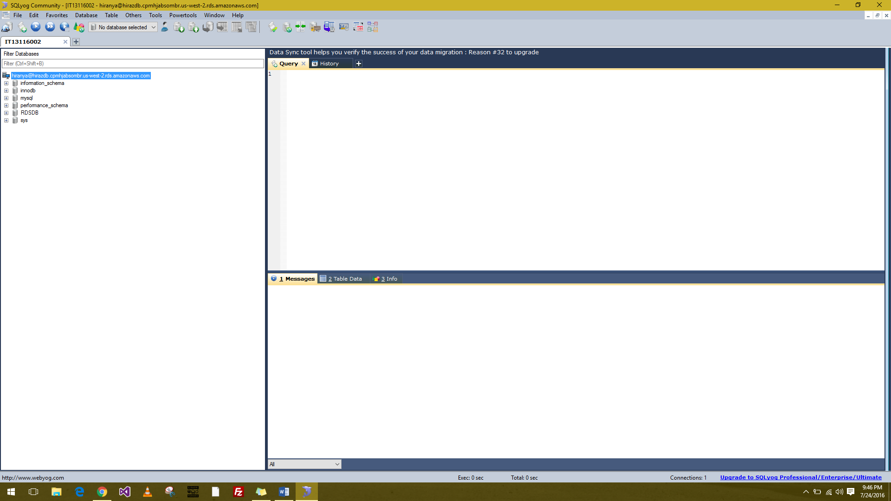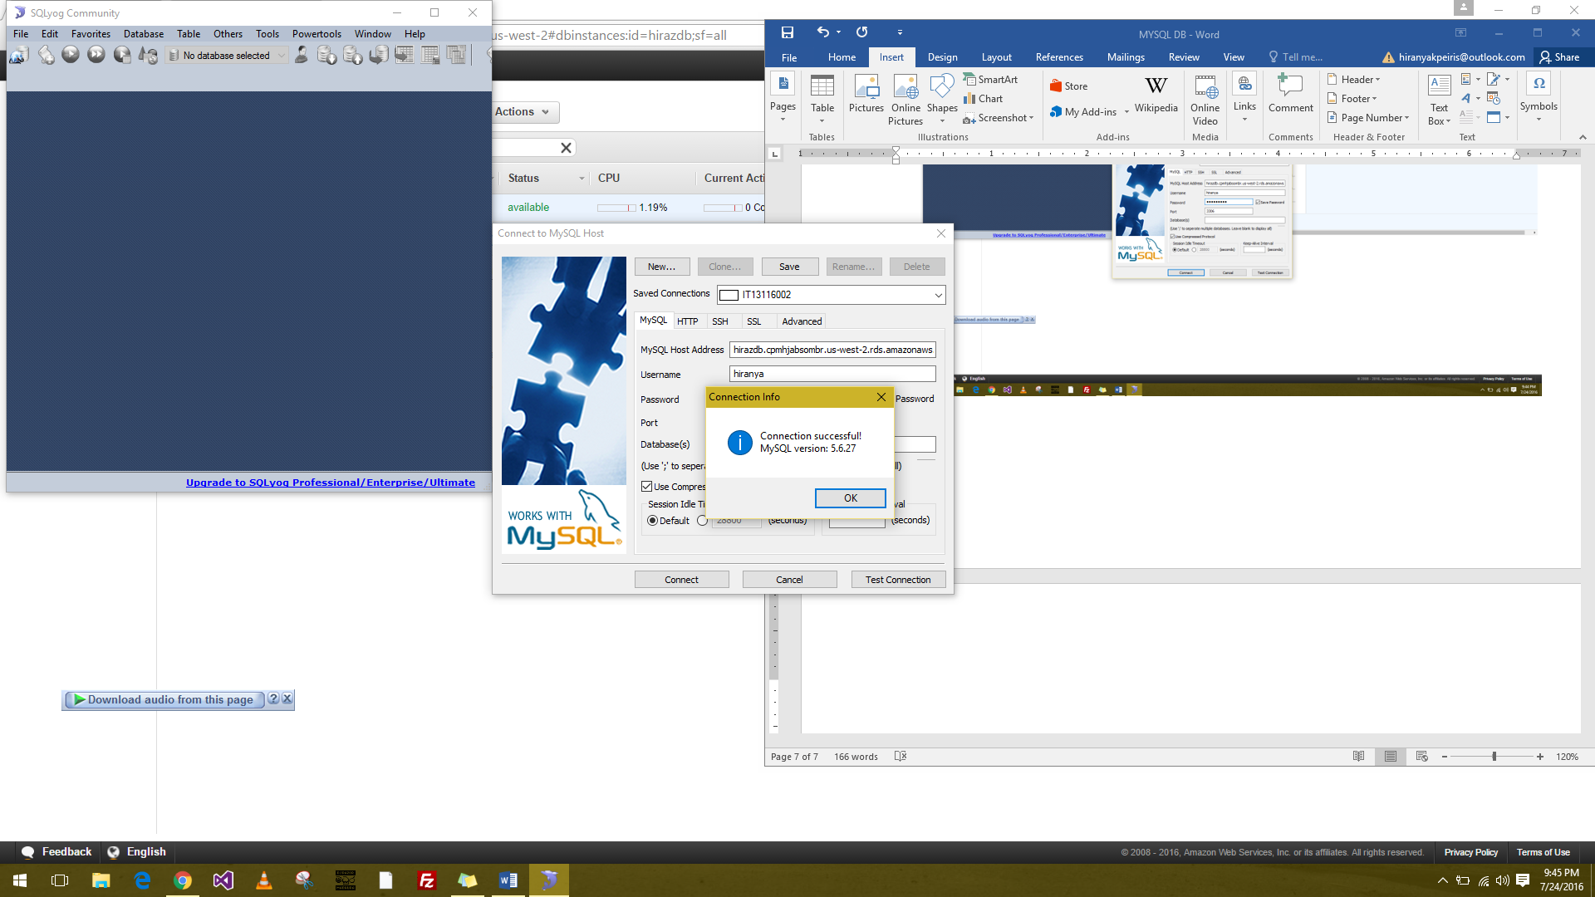

1. Exercise

